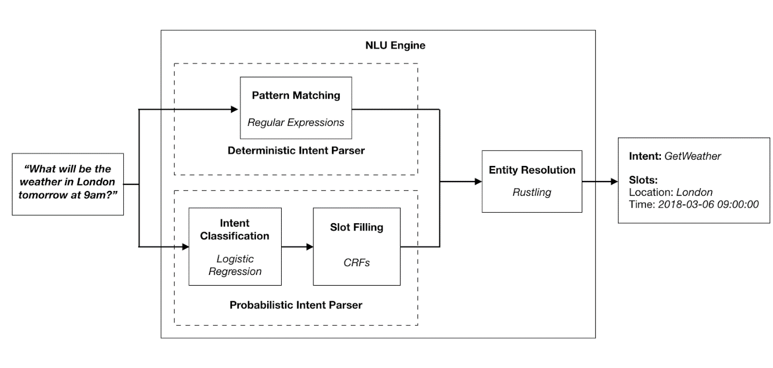

* 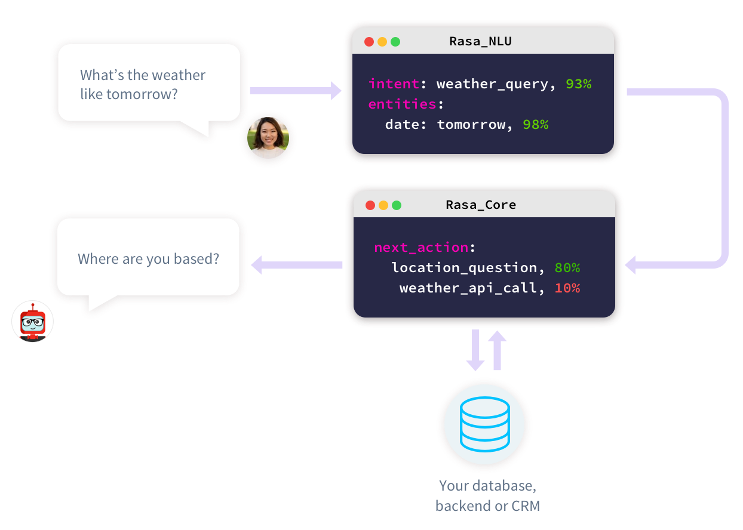
* Intent : Verb (reason to have a conversation)
* Entity :nouns (context i.e what is conversation about)
* Action: Operation performed by bot. Could be hard code reply or some other API response
* Stories: Sample interaction between user and bot defined in terms of intents captured and action performed.
* Domain: response against users# request. What is your response to that query? It is about intents, entities , action and response.
* Slots: bot’s memory. There are two ways to set slots

Slots set from NLU or Slots set by Actions

* Forms: conversational patterns to collect piece of information from user. It is used to maintain sequence and also to validate input,

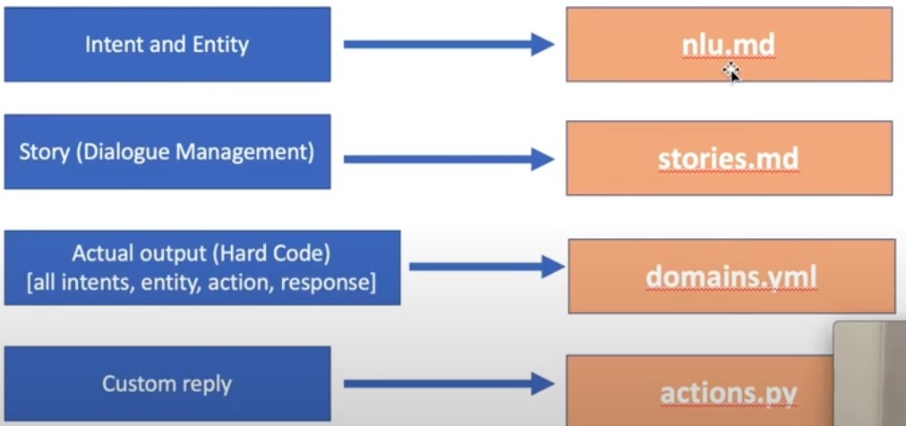

Rasa NLU: To find intent, train data, language support , choosing a pipeline , entity extraction

RasaCore: Dialogue handling

**For Coding**

* rasa init

(to initialize rasa environment)

* rasa shell

(to run code for checking standard bot using nlu.md, stories.md, domain.yml files)

* rasa train

(to train model if modify data)

* rasa run actions

(to run code from actions.py in case of customized model)

**For Building dataset**

**Step 1:** ==To Install==

Go inside the folder where you have data.json file and then give command:

npm install -g rasa-nlu-trainer

**step2**:

rasa-nlu-trainer